**VS code Project Setup**

1. **npm install [react@18.2.0](mailto:react@18.2.0)**

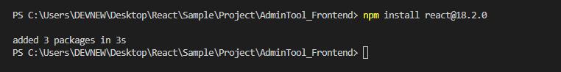

1. **npx create-react-app {project name}**

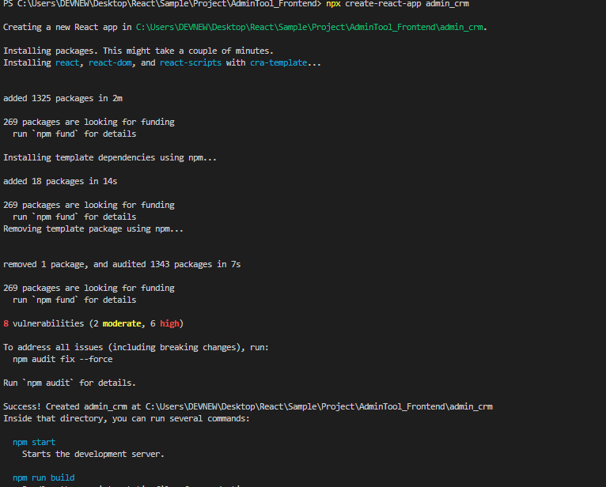

1. **Cd admin_crm**



1. **npm install ajv@latest ajv-keywords@latest**

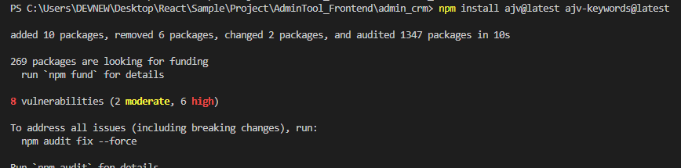

1. **npm install react-router-dom**

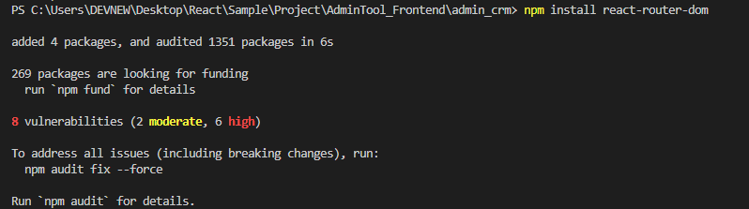

1. **npm install react-icon**

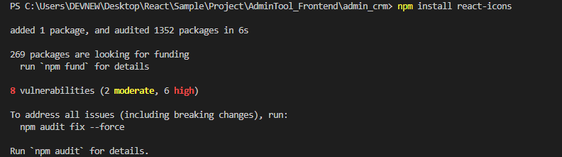

1. **npm i axios**

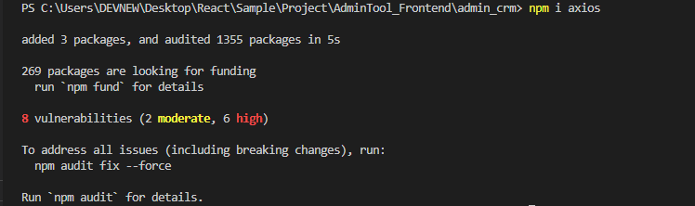

1. **npm install react select**

